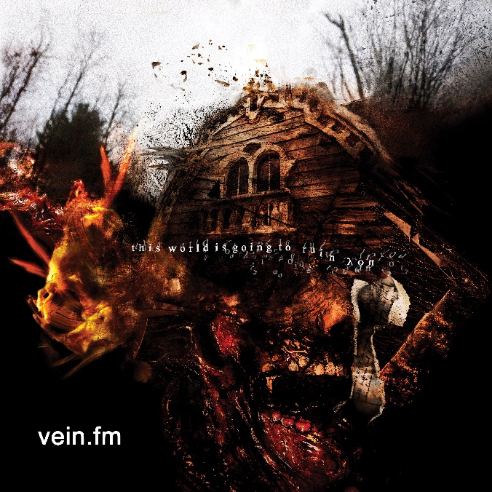

VEIN.FM

»This World Is Going
To Ruin You«

OUT: March 4th, 2022
Line up: | VEIN.FM online:
Anthony DiDio | Vocals  John Lhaubouet | Bass, Vocals  Jeremy Martin | Guitar, Vocals  Benno Levine | Samples, Turntable  Matt Wood | Drums | www.instagram.com/vein.fm  www.facebook.com/veinma  www.twitter.com/veinband  www.veintv.net  www.veinband.bandcamp.com/
“You're born into the world as a blank canvas. As you meet people and experience things, you’re getting stained and torn up.”

That’s VEIN.FM vocalist Anthony DiDio explaining the concept behind the band’s new record, This World Is Going To Ruin You. “This album is a response to everything we went through as a band from the time Errorzone was released until we recorded this one,” he says. “Between our personal lives and our life together as a band, there was a lot of stuff to navigate.”

Clearly, a lot has happened since the Massachusetts genre-smashers dropped Errorzone in 2018. DiDio and his bandmates—guitarist Jeremy Martin, bassist Jon Lhaubouet and drummer Matt Wood—did their first US headlining tour. They supported Every Time I Die’s 20th anniversary tour with Turnstile and Angel Dust. They did their first UK headlining tour and played their first shows in Japan. In 2019, they welcomed turntablist and electronics wizard Benno Levine into the band. Then everyone plunged into the death spiral of a global pandemic.

As panic and confusion gripped humanity, the band made a move to change their name. “We took advantage and made something cool out of it. Vein.tv was our Instagram, so the idea was to do another extension like that—VEIN.FM.”

The newly christened VEIN.FM recorded This World Is Going To Ruin You with Grammy winning producer Will Putney in April 2020, just weeks into pandemic lockdown. “It was crazy because COVID had just hit and nobody knew what was going on,” DiDio says. “There was a lot of stress from everybody around us, like, ‘Hey, if you’re going to make this album you might come home with this disease and kill everyone around you.’ Plus, we recorded in New Jersey, which was one of the worst place for COVID at the time. There was massive pressure to not do it, but obviously it was all we wanted to do.”

For maximum safety, the band members locked themselves inside the studio. No one could leave and no one could enter. “I think that was beneficial to productivity because everybody had to stay inside and be focused,” DiDio offers. “We would’ve done that anyway, but the great sense of danger sort of helped the process in a way. I’m glad we did it, because if we hadn’t, who knows when we would’ve gotten it done?”

While Errorzone was hailed by Pitchfork stating “sets the tone for one of the year’s most exhilarating heavy records.” This World Is Going To Ruin You will be hailed as its own formidable beast. “Every release is like its own universe,” DiDio explains. “It has to do with the look and the feel. On Errorzone, it’s pretty obvious: Everything is very colorful and bright, and there's electronic drum and bass elements. If you listen to our material prior to that, it’s much darker and much more disgusting.”

In that sense, This World Is Going To Ruin You is not a return to the band’s roots so much as a more fully realized version of them. “With this album, the vibe was to tune lower, make it darker and more disgusting, to sort of go back to the origin point of VEIN and put it on blast,” DiDio explains. “But it’s not a nostalgia trip. We’re just taking that part of the band to its fullest potential.”

Lyrically, This World Is Going To Ruin You describes the human condition through a birth-to-death timeline. “I was coming from a very anti-social mentality,” DiDio explains. “There was a lot of feeling of being taken advantage of, so it’s like a wounded animal or a scared child getting revenge. The opening song is almost like instructions on how to listen to the record. It’s basically telling you to let go of everything. And then the next song, ‘Killing Womb’, is a depiction of what the outside world is like.”

While DiDio doesn’t want to demystify the album’s lyrics, he will say this: “A lot of it has to do with death, life and the aging process. There’s songs about loss. There’s other songs that are much more abstract but have a relatable message of rediscovering yourself—of becoming lost in what the world can bring and coming back to your origins.”

This World Is Going To Ruin You includes guest appearances on three songs. “All the guest vocalists on the album are heroes of ours,” DiDio points out. “We’re not using guest vocalists as a way to get anyone’s attention or boost our song by getting some guy we don’t give a shit about to sing on it. It’s a way of putting our influences on our sleeves a bit, but we also used them in a way that made sense. Having their spirits on the album is very important. It’s like a dream come true for us.”

“Fear In Non Fiction” features guest vocals from Thursday frontman Geoff Rickly. “Thursday have been a massive influence on us growing up,” DiDio says. “They’re a band we’ve always looked up to. We got to tour with them in 2019, and when ‘Fear In Non Fiction’ was written, the middle part just called out for a guest vocal spot. Geoff’s voice fit the part, so it made perfect sense to have him on it.”

Jeff Smith from Connecticut screamo veterans Jeromes Dream appears on “Hellnight.” “The song sounds absolutely nothing like Jeromes Dream, but it does borrow elements from that band,” DiDio explains. “He only has like four or five words on it, but when you hear it, it’s massive. “I can’t explain how great it is to have him on the record because Jeromes Dream were a huge part of how we evolved as songwriters.”

Meanwhile, the Michigan-bred rapper Bones appears on “Orgy In The Morgue.” “I’ve never met Bones, but back in 2013 and ’14, he was making a lot of art and music that resonated with us,” DiDio says. “We got in contact a couple of years ago, and we’ve got him on this song screaming instead of rapping. It’s not what he would usually do, but lyrically and thematically it fits him well.”

We could go on and on about This World Is Going To Ruin You, but at this point you should probably just listen to it. “I don’t really know what else I can get across that you can’t hear in the music,” DiDio concludes. “It’s in the artwork, it’s in the lyrics, it’s in the music. I want people to have their own experience with the album and everything that’s on it.”

